Genesis 6:9-8:22 (Flood Account in Genesis)
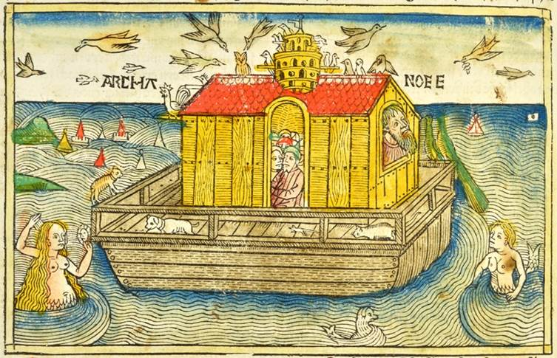
Mid-15th century woodcut that was included as an illustration in the Christian Bible (Figure 27 from Textbook)

6: 5 The Lord saw that the wickedness of humankind was great in the earth, and that every inclination of the thoughts of their hearts was only evil continually. 6 And the Lord was sorry that he had made humankind on the earth, and it grieved him to his heart. 7 So the Lord said, “I will blot out from the earth the human beings I have created—people together with animals and creeping things and birds of the air, for I am sorry that I have made them.” 8 But Noah found favor in the sight of the Lord. 9 These are the descendants of Noah. Noah was a righteous man, blameless in his generation; Noah walked with God. 10 And Noah had three sons, Shem, Ham, and Japheth. 11 Now the earth was corrupt in God’s sight, and the earth was filled with violence. 12 And God saw that the earth was corrupt; for all flesh had corrupted its ways upon the earth. 13 And God said to Noah, “I have determined to make an end of all flesh, for the earth is filled with violence because of them; now I am going to destroy them along with the earth. 14 Make yourself an ark of cypress wood; make rooms in the ark, and cover it inside and out with pitch. 15 This is how you are to make it: the length of the ark three hundred cubits, its width fifty cubits, and its height thirty cubits. 16 Make a roof for the ark, and finish it to a cubit above; and put the door of the ark in its side; make it with lower, second, and third decks. 17 For my part, I am going to bring a flood of waters on the earth, to destroy from under heaven all flesh in which is the breath of life; everything that is on the earth shall die. 18 But I will establish my covenant with you; and you shall come into the ark, you, your sons, your wife, and your sons’ wives with you. 19 And of every living thing, of all flesh, you shall bring two of every kind into the ark, to keep them alive with you; they shall be male and female. 20 Of the birds according to their kinds, and of the animals according to their kinds, of every creeping thing of the ground according to its kind, two of every kind shall come in to you, to keep them alive. 21 Also take with you every kind of food that is eaten, and store it up; and it shall serve as food for you and for them.” 22 Noah did this; he did all that God commanded.

7: 1 Then the Lord said to Noah, “Go into the ark, you and all your household, for I have seen that you alone are righteous before me in this generation. 2 Take with you seven pairs of all clean animals, the male and its mate; and a pair of the animals that are not clean, the male and its mate; 3 and seven pairs of the birds of the air also, male and female, to keep their kind alive on the face of all the earth. 4 For in seven days I will send rain on the earth for forty days and forty nights; and every living thing that I have made I will blot out from the face of the ground.” 5 And Noah did all that the Lord had commanded him. 6 Noah was six hundred years old when the flood of waters came on the earth. 7 And Noah with his sons and his wife and his sons’ wives went into the ark to escape the waters of the flood. 8 Of clean animals, and of animals that are not clean, and of birds, and of everything that creeps on the ground, 9 two and two, male and female, went into the ark with Noah, as God had commanded Noah. 10 And after seven days the waters of the flood came on the earth. 11 In the six hundredth year of Noah’s life, in the second month, on the seventeenth day of the month, on that day all the fountains of the great deep burst forth, and the windows of the heavens were opened. 12 The rain fell on the earth forty days and forty nights. 13 On the very same day Noah with his sons, Shem and Ham and Japheth, and Noah’s wife and the three wives of his sons entered the ark, 14 they and every wild animal of every kind, and all domestic animals of every kind, and every creeping thing that creeps on the earth, and every bird of every kind—every bird, every winged creature. 15 They went into the ark with Noah, two and two of all flesh in which there was the breath of life. 16 And those that entered, male and female of all flesh, went in as God had commanded him; and the Lord shut him in. 17 The flood continued forty days on the from the New Revised Standard Version earth; and the waters increased, and bore up the ark, and it rose high above the earth. 18 The waters swelled and increased greatly on the earth; and the ark floated on the face of the waters. 19 The waters swelled so mightily on the earth that all the high mountains under the whole heaven were covered; 20 the waters swelled above the mountains, covering them fifteen cubits deep.21 And all flesh died that moved on the earth, birds, domestic animals, wild animals, all swarming creatures that swarm on the earth, and all human beings; 22 everything on dry land in whose nostrils was the breath of life died. 23 He blotted out every living thing that was on the face of the ground, human beings and animals and creeping things and birds of the air; they were blotted out from the earth. Only Noah was left, and those that were with him in the ark. 24 And the waters swelled on the earth for one hundred fifty days.

8: 1 But God remembered Noah and all the wild animals and all the domestic animals that were with him in the ark. And God made a wind blow over the earth, and the waters subsided; 2 the fountains of the deep and the windows of the heavens were closed, the rain from the heavens was restrained, 3 and the waters gradually receded from the earth. At the end of one hundred fifty days the waters had abated; 4 and in the seventh month, on the seventeenth day of the month, the ark came to rest on the mountains of Ararat. 5 The waters continued to abate until the tenth month; in the tenth month, on the first day of the month, the tops of the mountains appeared. 6 At the end of forty days Noah opened the window of the ark that he had made 7 and sent out the raven; and it went to and fro until the waters were dried up from the earth. 8 Then he sent out the dove from him, to see if the waters had subsided from the face of the ground; 9 but the dove found no place to set its foot, and it returned to him to the ark, for the waters were still on the face of the whole earth. So he put out his hand and took it and brought it into the ark with him. 10 He waited another seven days, and again he sent out the dove from the ark; 11 and the dove came back to him in the evening, and there in its beak was a freshly plucked olive leaf; so Noah knew that the waters had subsided from the earth. 12 Then he waited another seven days, and sent out the dove; and it did not return to him anymore.13 In the six hundred first year, in the first month, on the first day of the month, the waters were dried up from the earth; and Noah removed the covering of the ark, and looked, and saw that the face of the ground was drying. 14 In the second month, on the twenty-seventh day of the month, the earth was dry. 15 Then God said to Noah, 16 “Go out of the ark, you and your wife, and your sons and your sons’ wives with you. 17 Bring out with you every living thing that is with you of all flesh—birds and animals and every creeping thing that creeps on the earth—so that they may abound on the earth, and be fruitful and multiply on the earth.” 18 So Noah went out with his sons and his wife and his sons’ wives. 19 And every animal, every creeping thing, and every bird, everything that moves on the earth, went out of the ark by families. 20 Then Noah built an altar to the Lord, and took of every clean animal and of every clean bird, and offered burnt offerings on the altar. 21 And when the Lord smelled the pleasing odor, the Lord said in his heart, “I will never again curse the ground because of humankind, for the inclination of the human heart is evil from youth; nor will I ever again destroy every living creature as I have done. 22 As long as the earth endures, seedtime and harvest, cold and heat, summer and winter, day and night, shall not cease.”

Ovid (Flood Account by Ovid)
Mid-16th century woodcut that was included as an illustration for a reprinted edition of Ovid’s text (1513 Woodcut Illustrating Ovid's Text).

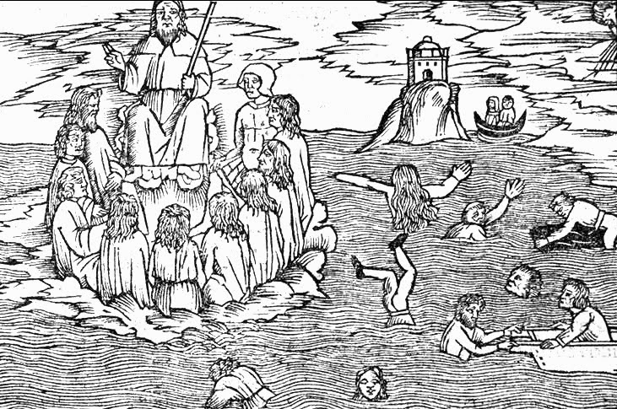
240 “One house has been punished, but not only one house was
241 Worthy to be destroyed. Where the earth is accessible, wild Furies rule.
242 It seems that everything is involved in crime; let them all swiftly
243 Pay the penalties, which, in my opinion, they deserve to suffer.”
244 When the words of Jove were spoken, part of the audience shouted their approval
245 And spurred on his raging. The other part showed their approval with applause.
246 Nevertheless, there is grief for all with the loss of the human race,
247 And they ask what might be the future form for the land bereft of mortals.
248 They ask who is going to bring offerings to altars.
249 They ask whether he would prepare to handover the lands to wild beasts to be ravaged.
250 The king of the gods prohibited those inquiring such things to be afraid,
251 For the details would be his concern, and he promises offspring
252With an amazing origin, dissimilar to the previous people.
253 And now he was about to scatter thunderbolts across the whole lands,
254 But he feared that perhaps the sacred ether would catch the flames
255 Of so much fire and that the boundless sky would catch fire.
256 He remembered that it was fated that there would be a time when the sea, the earth,
257 And the palace of the sky, having caught fire,
258 Would burn and the smothered mass of the world would be in distress.
259 The weapons that were fabricated by the hands of the Cyclopes were put away.
260 A different punishment pleased him: to destroy the human race under water
261 And to send rainstorms from the whole sky.
262 Immediately, he closes the North Wind into the cave of Aeolus
263 And whatever gusts led the clouds to flee.
264 Also, he discharges the South Wind. The South Wind rushes forth with wet wings,
265 Covering his frightful face with pitch black fog;
266 His beard is heavy with rain, water flows from his white hair,
267 Fog is sitting at his forehead; his wings and lap are dripping.
268 And just as he pressed against the hanging clouds with his broad hand,
269 A crash happens; from here, dense rains are poured from the sky.
270 Iris, [goddess of the rainbow and] messenger of the gods, having clothed herself in various colors,
271 Draws up waters and brings it to the clouds as fuel.
272 The crops are scattered and the miserable offerings of the farmers
273 Lie in ruin, and the useless labor of the long year perishes.
274 The anger of Jove is not content with just his sky, but
275 His sea-god brother [Neptune] helps him with auxiliary waters.
276 He calls the rivers, and after they reached the halls of
277 Their master, Neptune stated, “Now must not be spent on a long diatribe.
278 Pour forth your strengths
279 It is necessary for you to open your homes and by removing a large damn
280 From your rivers, let go of your reins all at once.”
281 Thus he had ordered. The rivers return and they widen the mouths of their fountains
282 And they roll along on an unrestrained course onto the plains.
283 Neptune himself strikes the earth with his trident and the earth
284Trembled and with this movement and exposed pathways for the waters.
285 The wandering rivers rush on through the open fields
286 And with things having been scattered, at the same time crops and herds and men
287 And roofs, as well as temples along with their sacred things, were destroyed.
288 If any house remained intact and was able to resist
289 So much disaster, nevertheless a rather high wave covered
290 Its roof and its towers, overwhelmed by water, lie under the flood.
291 And now there was no difference between the sea and the earth.
292 Everything was the sea, and the shores were missing from the sea.
293 One man occupies a hill-top, another sits in his curved skiff
294 And he rows oars in the place where he recently plowed.
295 Another man sails over his crops and the roofs of his immersed villa.
296 This man catches a fish in the tallest elm.
297 As luck would have it, an anchor is fixed in a green meadow,
298 Or curved ships are sailing over nearby vineyards;
299 And, where the slender goats had recently grazed on grass,
300 Now the flexible seals place their bodies there.
301 The Nereides [sea-nymphs] marveled at the groves and cities and homes
302 Under the water. Dolphins possess the woods and against the high
303 Branches they strike and they beat the shaken oak trees.
304 The wolf swims among sheep. The wave carries yellow lions.
305 The wave carries tigers. And strong tusks are no longer
306 Advantageous to the boar, nor are swift legs advantageous to the stag.
307 And after searching the lands for a long time for a place where he is able to land,
308 The wandering bird sinks into the sea with exhausted wings.
309 The immense disorderliness of the sea had covered up the hills
310 And the extraordinary waves beat against the mountainous peaks.
311 The greatest part of everything was destroyed by the water. For those to whom the water
312 Showed consideration, hunger from lack of nourishment conquered them.
313 [In the Northern part of Greece] Where Phocis separates the Boetian from the Oetian fields
314 The land was fertile while it was land, but at this time it is
315 Part of the sea and a widefield of water was placed over it.
316 There, a steep mountain with two peaks that seek the stars,
317 Named Parnassus, and the peaks are above the clouds.
318 Here is where Deucalion clung, along with his wife[Pyrrha],
319 They were carried by a little boat. The water had covered the rest of everybody.
320 The couple worships the local nymphs and the gods of the mountain
321 And prophetic Themis, who, at that point, was in charge of the oracles.
322 There was not any man better than this one, nor anyone more loving of justice.
323 And there was not any woman more fearing of the gods.
324 Jupiter, just as he sees that the world is under water with flowing marshes
325 And that only one man survived from the whole thousands
326 And that only one woman survived from the whole thousands,
327 Both are innocent, both worshippers of god,
328 He breaks up the clouds. And when the North Wind had scattered the clouds,
329 Jupiter showed the lands to the sky and the ether to the lands.
330 The anger of the sea does not remain and Neptune puts down his trident.

